Reclamation District 799

Beaver Repair Project
Total Repair Cost: $14,074.22

Before

. 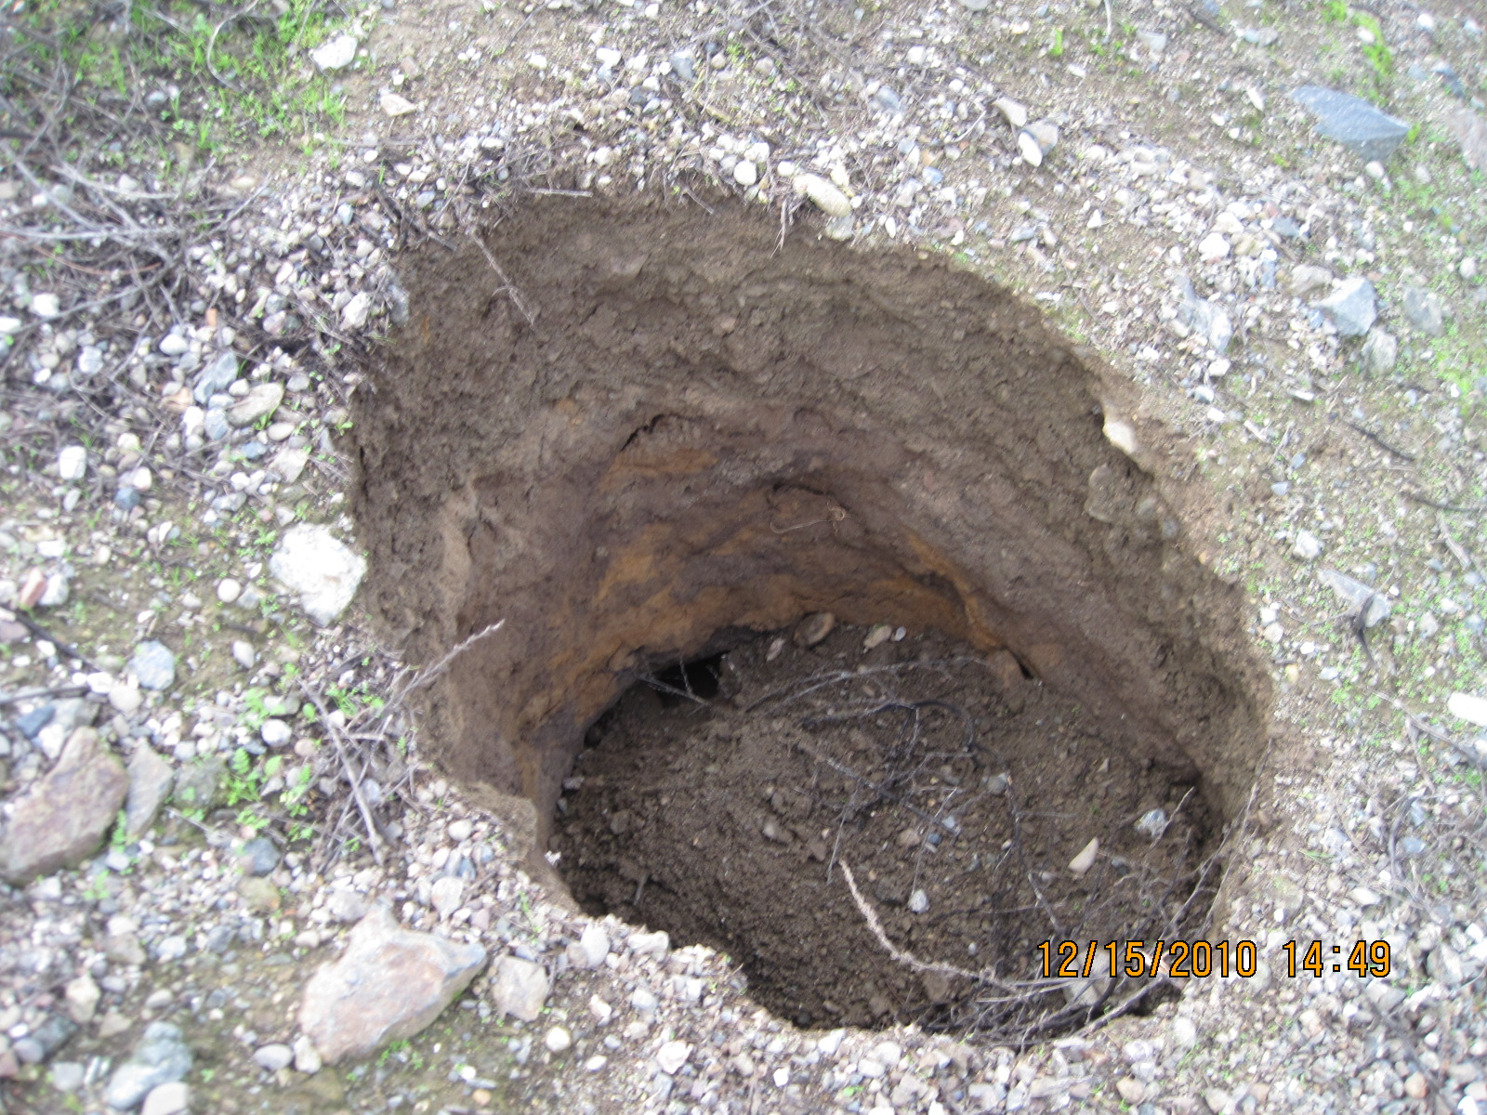
After
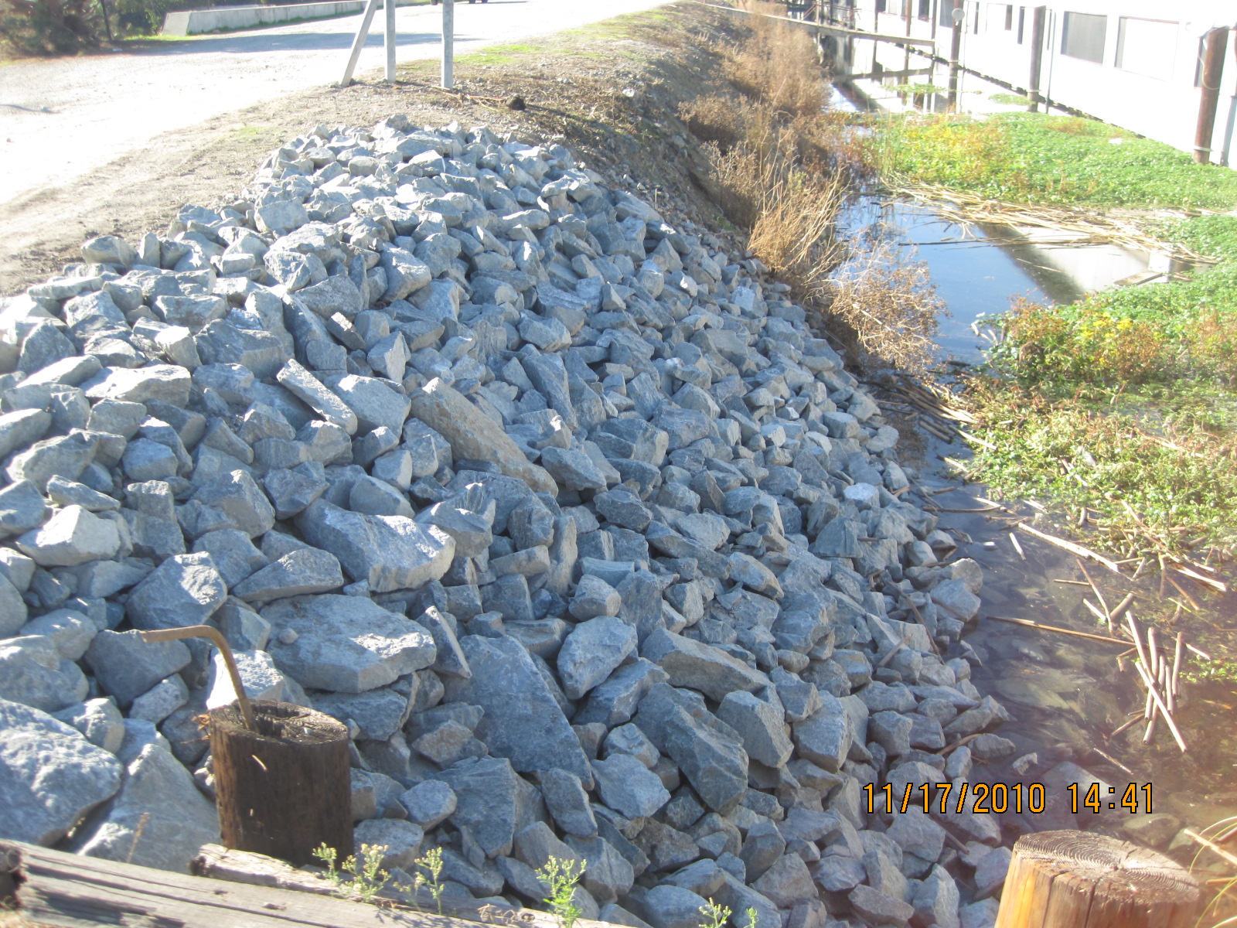

The Beaver:

The beaver is a large North American Rodent and is nature’s equivalent of a habitat engineer. Beavers create ponds and wetlands used by waterfowl, shorebirds, muskrats, otters, fish, amphibians, aquatic plants and other living species. Beaver ponds generally slow the water flow from drainage areas and alter silt deposition, thus creating new habitat. During drought conditions, beaver ponds create water holes for livestock and wildlife, particularly waterfowl. However, the engineering feats cause problems when they (1) flood homes, roads, croplands and timberlands. (2) Dam canals, drainages and pipes, which inhibits water control, or (3) girdle and fell or flood valuable trees, thus causing them to die after prolonged flooding.

Natures Engineering:

Signs of a beaver are usually quite evident. If there are beavers in the areas, you can spot their tree cutting and girdling activity or they may have chewed into your docks. After building a dam, beaver normally build bank dens or ledges out of sticks and mud. By damming a steam, beaver flood the bushes and trees which server as their primary flood source. Ponds also service as a place to escape, since a beaver can remain under water for a long period of time. They usually use bank dens in steams or where water levels fluctuate often, or lodges made of stick and mud in shallow-water areas formed by their dams. Enter their dens below the water levee, but their living quarters are high and dry above the water level. Active lodges are easily recognized by fresh cutting and mud on the lodge. There may be more than one colony of beaver in a large beaver pond or lake, but each colony defends its own territory.

Pictures of Actual Beaver Dams in the RD799 Pump Stations:

Before:
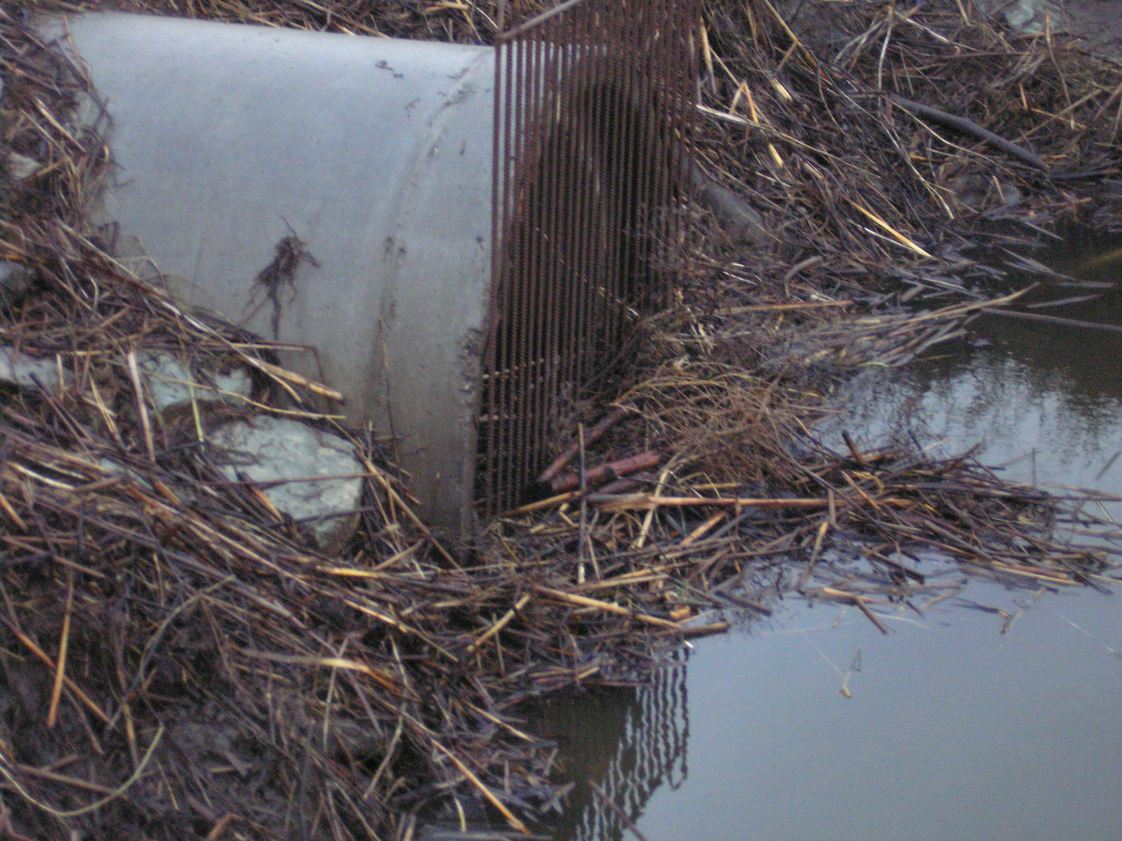
After
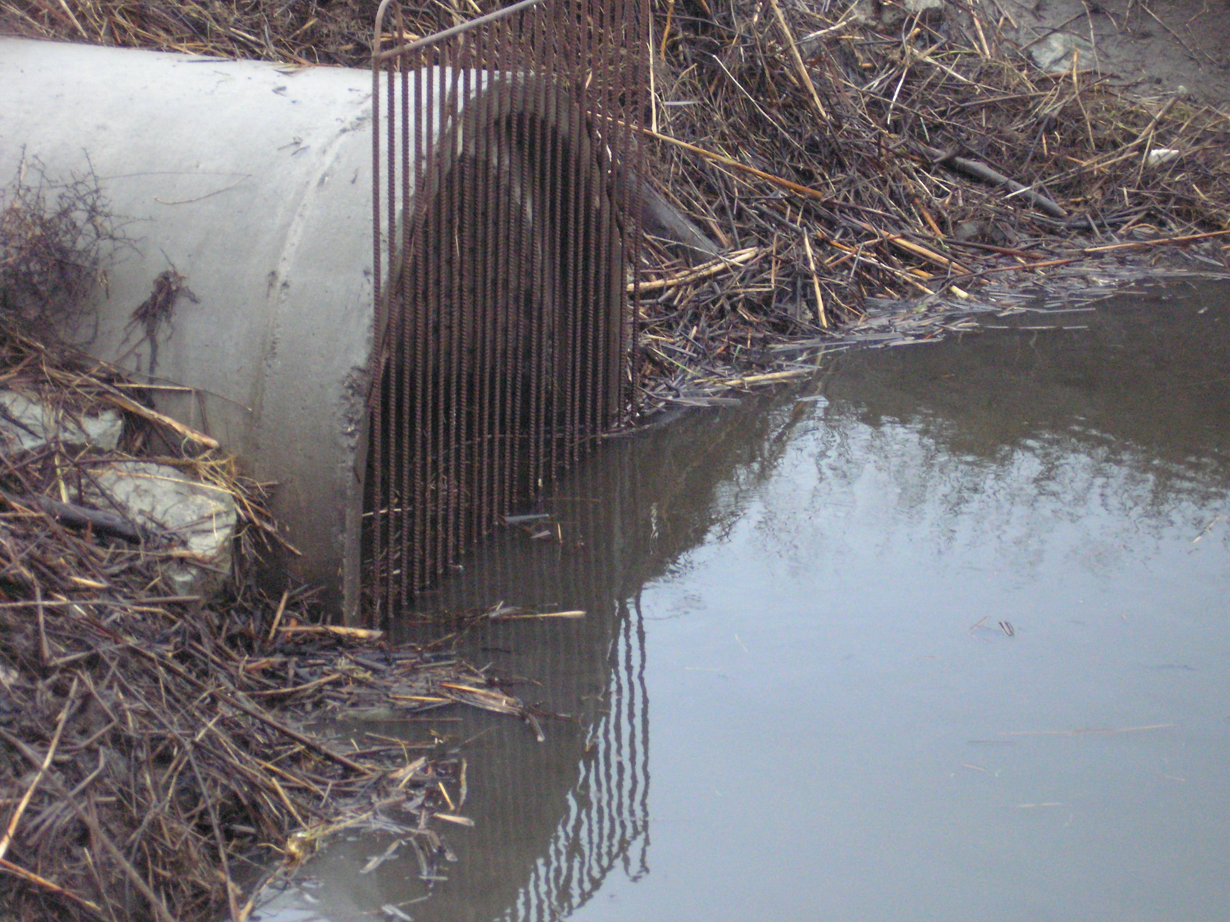

RD799’s Beaver Dam Control:

Reclamation District’s personnel conduct daily routine beaver dam inspections. During the late hours into the night beavers are hard at work engineering and building beaver dams. The dams are built either in front of or behind our drainage grates. The beaver’s dams cause a blockage and does not allow for the water level in the ditch to drain. The water levels in the ditch begin to rise. This can cause potential damage to the i
sland.

The following picture demonstrates the amount of debris that can come from one beaver dam.

Restoration of Water Flow:

This picture demonstrates the water level being lowered once a beaver dam has been cleared from either in front or behind the grate.



